Compte-rendu Persyval CEE
Circuit power consumption is closely related to data processing. This observation is the foundation of our new low-power approach based on a non-uniform sampling scheme combined with asynchronous event-driven logic. This will be useful for handheld computing systems and mobile applications such as wireless solutions for telemetry and metering, medical implants and more generally for “Internet of Things” applications. These applications required a very low level of consumption because they can remain active during several years. Our case study is applied to physiological signals used in a medical implant and shows a drastic reduction of the power consumption compared to the classical approach.
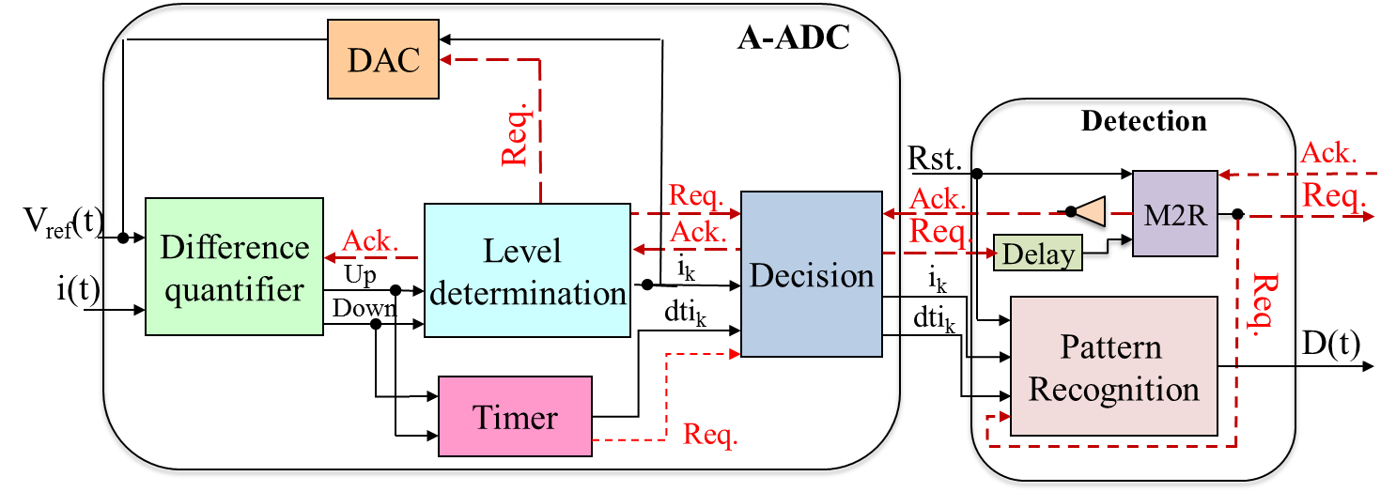
Figure 1: A-ADC and physiological signal pattern recognition Architecture
The circuit is designed to recognize a set of predefined physiological signal patterns. The pattern recognition is performed thanks to a non-uniform sampling scheme (LCSS in this case) and an event-driven logic. The combination of the non-uniform sampling and of the event-driven logic allows to drastically reduce the number of samples and to only activate the computation when there is new data. The gain is spectacular because we are able to gain two orders of magnitude on the power consumption just by sampling differently. Moreover, the asynchronous processing is, in this case, simpler and another order of magnitude can be gained (see).
Table 1: Comparison between the asynchronous and synchronous approaches
Set | Time (s) | Nb. of Samples | % of synch. Samples | Energy nJ/pattern | pAh/ pattern | Gain (%)
1 | 38,3 | 3830 | 1,4 | 3087 | 259 | 99,80
2 | 1 14,6 | 11465 | 0,4 | 9236 | 777 | 99,93
3 | 54,5 | 5453 | 1,0 | 3182 | 535 | 99,84

This method is application and signal specific and such gains will not be obtained in any case. Nevertheless, we can claim that this approach should be considered case by case. This particular application highlights the potential in reducing the power consumption when considering the entire processing chain. This also points out that determining the appropriate sampling scheme is the key for drastically minimizing the power.
References
Tugdual Le Pelleter, Taha Beyrouthy, Robin Rolland-Girod, Agnès Bonvilain, Laurent Fesquet, “Non-uniform Sampling Pattern Recognition Based on Atomic Decomposition”, 10th International Conference on Sampling Theory and Applications (SampTA 2013), Jacobs University, Bremen, July 1st - July 5th, 2013

